This is a use case to showcase the power of Salesforce Health Cloud + AgentForce (AI automation) to create a modern, empathetic, and operationally excellent Patient Services Call Center.

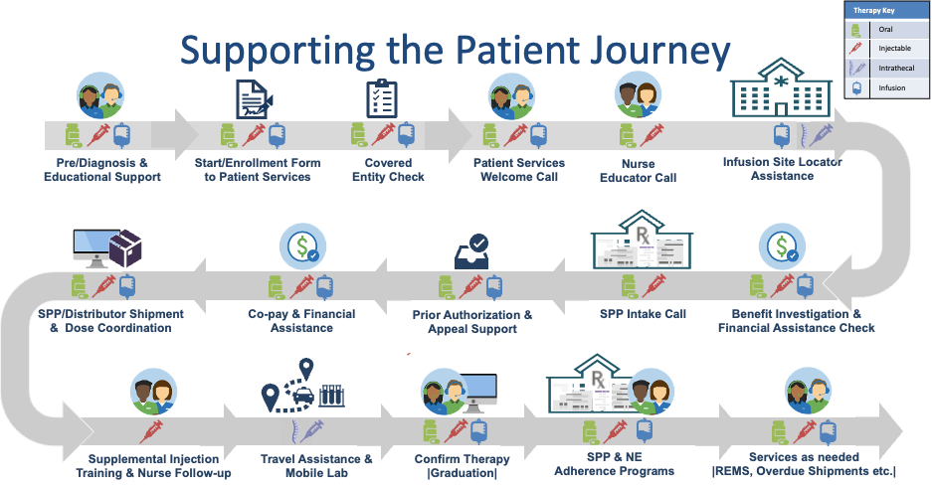

Below is a step-by-step demo scenario using your “Supporting the Patient Journey” workflow, mapped to Salesforce capabilities, AgentForce automations, and patient/agent interactions for Sarah Parker (patient) and Cindy Smith (Patient Services Agent at Biogen).

**Scenario Overview**

Patient: **Sarah Parker** (New MS Patient)  
Therapy: **Tysabri** (Infusion Therapy for Multiple Sclerosis)  
PS Agent: **Cindy Smith** (Biogen Patient Services)  
Goal: Seamless onboarding and therapy initiation with visibility, automation, and empathy — like an “Amazon delivery” experience for specialty therapy.

**Key Demo Aspects:**

* End-to-end visibility: Patient sees everything like an Amazon delivery tracker.
* Empathetic human + AI: Cindy uses AgentForce to focus on care, not admin.
* Operational excellence: Automation reduces PA/Bi wait times dramatically.
* Scalability: This flow can support thousands of patients with minimal manual overhead.

**Core Systems Used:**

* Salesforce Health Cloud – Patient 360, Care Plans, Provider Network, PA/BI workflows
* AgentForce – AI copilots and automated task orchestration for call center and patient engagement
* Salesforce Mobile Experience – Patient-facing dashboard for real-time status & reminders

**STEP-BY-STEP DEMO FLOW**

1. **Diagnosis & Start Form Submission**

* Event: Sarah visits her neurologist → Diagnosed with MS → Prescribed Tysabri.
* Action: HCP e-submits Start Form → triggers Salesforce Health Cloud intake record.
* System:
  + Health Cloud auto-creates a Patient Profile with demographic, insurance, and therapy info.
  + AgentForce extracts key data (therapy type, insurance, physician, site preference) using LLM-based form parsing.

Demo: Show Health Cloud intake record auto-populating fields. AgentForce flags missing data for Cindy.

2. **Covered Entity Check**

* Actor: Cindy Smith (PS Agent)
* Action: Cindy verifies provider eligibility in Covered Entity Network.
* System:
  + Health Cloud Provider Network → Auto-match HCP NPI and site ID.
  + AgentForce recommends next steps if site not covered (e.g., alternate site suggestion).

Demo: Cindy clicks “Verify” → AI auto-suggests nearest covered site if mismatch.

3. **Patient Services Welcome Call**

* Actor: Cindy calls Sarah.
* System:
  + Health Cloud Care Plan auto-generates Welcome Call Script using AgentForce Copilot.
  + Sarah’s record is updated with consent preferences, communication channels (SMS, mobile app), and language.
* Outcome: Sarah is onboarded empathetically.

Demo: Show Agent Console with copilot-suggested empathetic script, sentiment analysis live.

4. **Nurse Educator Call**

* Actor: Tysabri Nurse Educator
* System:
  + Health Cloud task auto-assigned to Nurse queue.
  + AgentForce generates education checklist tailored to therapy.
* Outcome: Sarah receives disease & therapy education, injection guidance.

Demo: Show task routing automation & generated nurse script in console.

5. **Infusion Site Locator**

* Action: Sarah chooses infusion site based on location & availability.
* System:
  + Health Cloud Provider Directory + Geolocation API.
  + AgentForce suggests top 3 sites based on travel time, REMS certification, and availability.

Demo: Show site selection on map UI within Sarah’s patient record.

6. **Benefits Investigation & Financial Assistance**

* Actor: Cindy / Automated AgentForce
* System:
  + AgentForce triggers BI & FA workflows:
    - Pulls payer info
    - Checks eligibility
    - Triggers Copay program if needed
  + Auto-notifies Cindy once BI is clear.

Demo: Show BI task moving from “Pending” → “Approved” automatically with notifications.

7. **SPP Intake Call & PA/Appeals**

* Actor: Cindy / AgentForce
* System:
  + Health Cloud → Specialty Pharmacy record creation, linking to Sarah’s infusion site.
  + AgentForce triggers Prior Authorization submission, monitors payer portals, and alerts Cindy of approvals.
  + Appeals auto-generated if PA is denied.

Demo: Show PA dashboard with AgentForce bot checking payer portal every 4 hours and auto-closing once approved.

8. **Copay & Financial Assistance**

* System:
  + AgentForce evaluates Sarah’s insurance + household income to auto-qualify for Copay assistance.
  + Enrolls Sarah automatically if criteria met, notifies Cindy for review.

Demo: Show Copay program enrollment with auto-generated documentation in Sarah’s record.

9. **SPP Shipment Coordination**

* System:
  + Health Cloud integrates with Specialty Pharmacy shipping system.
  + AgentForce generates shipment tracking number and updates Sarah’s dashboard (similar to Amazon delivery tracking).

Demo: Sarah’s mobile dashboard shows “Tysabri shipment arriving at Infusion Site – ETA: Nov 18”.

10. **Infusion Visit & Support**

* System:
  + Health Cloud calendar tracks infusion appointment.
  + AgentForce sends automated SMS reminders for appointment, travel assistance, Uber booking link.
  + Nurse Educator follow-up is auto-triggered after infusion completion.

Demo: Show infusion reminder notification on Sarah’s mobile dashboard + agent’s activity timeline.

11. **Therapy Confirmation & Graduation**

* Actor: Cindy
* System:
  + After first infusion, Cindy confirms completion → clicks “Mark Graduation” in Health Cloud.
  + AgentForce auto-updates patient journey status to “On Therapy”, triggers adherence program enrollment.

Demo: Graduation badge appears on Sarah’s mobile dashboard.

12. **Adherence, REMS & Ongoing Support**

* System:
  + Health Cloud Adherence Program monitors shipment dates, infusion schedules.
  + AgentForce sends automated reminders, flags missed infusions.
  + Tracks REMS compliance & auto-logs AE/SAE reports to regulatory module.

Demo: Sarah gets push notification: “Next infusion in 3 days at Stanford Infusion Center. Uber scheduled for pickup at 8:30 AM ”.

Sarah’s Mobile Dashboard (Patient App View)

Modules:

* ✅ Therapy Onboarding Status → visual tracker like Amazon delivery
* 🏥 Infusion Schedule → Calendar + Reminders
* 🚗 Travel Assistance → Uber booking & reimbursement info
* 🎓 Patient Graduation → Milestone badge & congratulatory message
* 💬 Secure Messaging → Chat with Nurse or PS Agent
* 📄 Documents → BI/PA approval letters, educational materials

**AgentForce Automations Highlight**

| Automation Area | AgentForce Function |
| --- | --- |
| Start Form Intake | LLM-based form parsing, patient creation |
| Covered Entity Check | Site match + fallback recommendations |
| Welcome Call | AI Copilot script + sentiment analysis |
| BI/FA | Automated payer API checks |
| PA/Appeals | Continuous monitoring + appeals generation |
| Copay Assistance | Eligibility logic + enrollment |
| Shipment Tracking | Real-time status integration |
| Infusion Reminders | SMS/Push automation |
| Adherence | Missed infusion alerts |
| REMS | AE detection & reporting |